SACHSE PUBLIC LIBRARY - PROGRAM SERIES for ADULTS
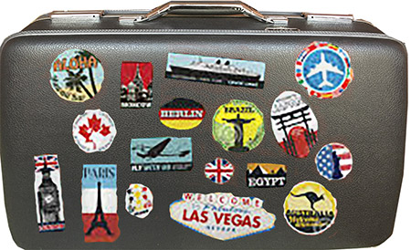
October 4, 2018-at the library-6:30-7:30 p.m.

Tripping: Practical Planning and Packing
- Do you fold or roll the clothes?
- Which works better?
- What MUST you carry vs. packing in your suitcase?
- What type of suitcase works best?
- Are your TSA and other documents secure?
- What type suitcase works best?

Join us for a jam-packed presentation and discussion to help your next phenomenal trip. Ruth Glover has traveled internationally since she was a child. She claims she’s made more mistakes than many, improving with each adventure. This interactive program shares quick stories for examples, products to help and a free checklist to improve your next exciting train, plane, or automobile trip.
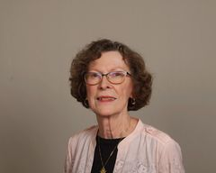
Ruth Glover, local author, writes and speaks about uncommon people and places. Her writing provides insight about big cities and small towns. Whether it’s a river cruise or road trip, Ruth’s articles and programs allow you to envision lofty mountains, sandy seashores, and dazzling scenery with reality and unexpected incidents.
Ruth grew up in Ohio and is a long-time Texas resident. She has lived in eight different states and visited a dozen countries. She is founder of the Sachse-Wylie Authors Group, and enjoys family, friends, volunteer work, and reading.

